**Technical & Functional analysis**

**Breakout game with accelerometer controller using Thread/Matter**

|  |  |
| --- | --- |
|  |  |

Date :

Contacts : Dekimo :

Table of Contents

1. Project overview 3

2. Matter protocol 3

3. OpenThread network protocol 3

4. Game controller 4

4.1. EFR32MG24 - BRD2601B Dev Kit 4

4.2. EFR32MG24 Wireless SoC 5

5. ICM-20689 5

5.1. Product Overview 5

5.2. Technical specifications 8

# Project overview

This project is an interactive breakout game controlled by motion with a wireless controller. The controller is connected to a Thread network and communicates with the Matter protocol. The breakout game is displayed on a tv using a SBC (Single Board Computer) that is also connected to a Thread network.

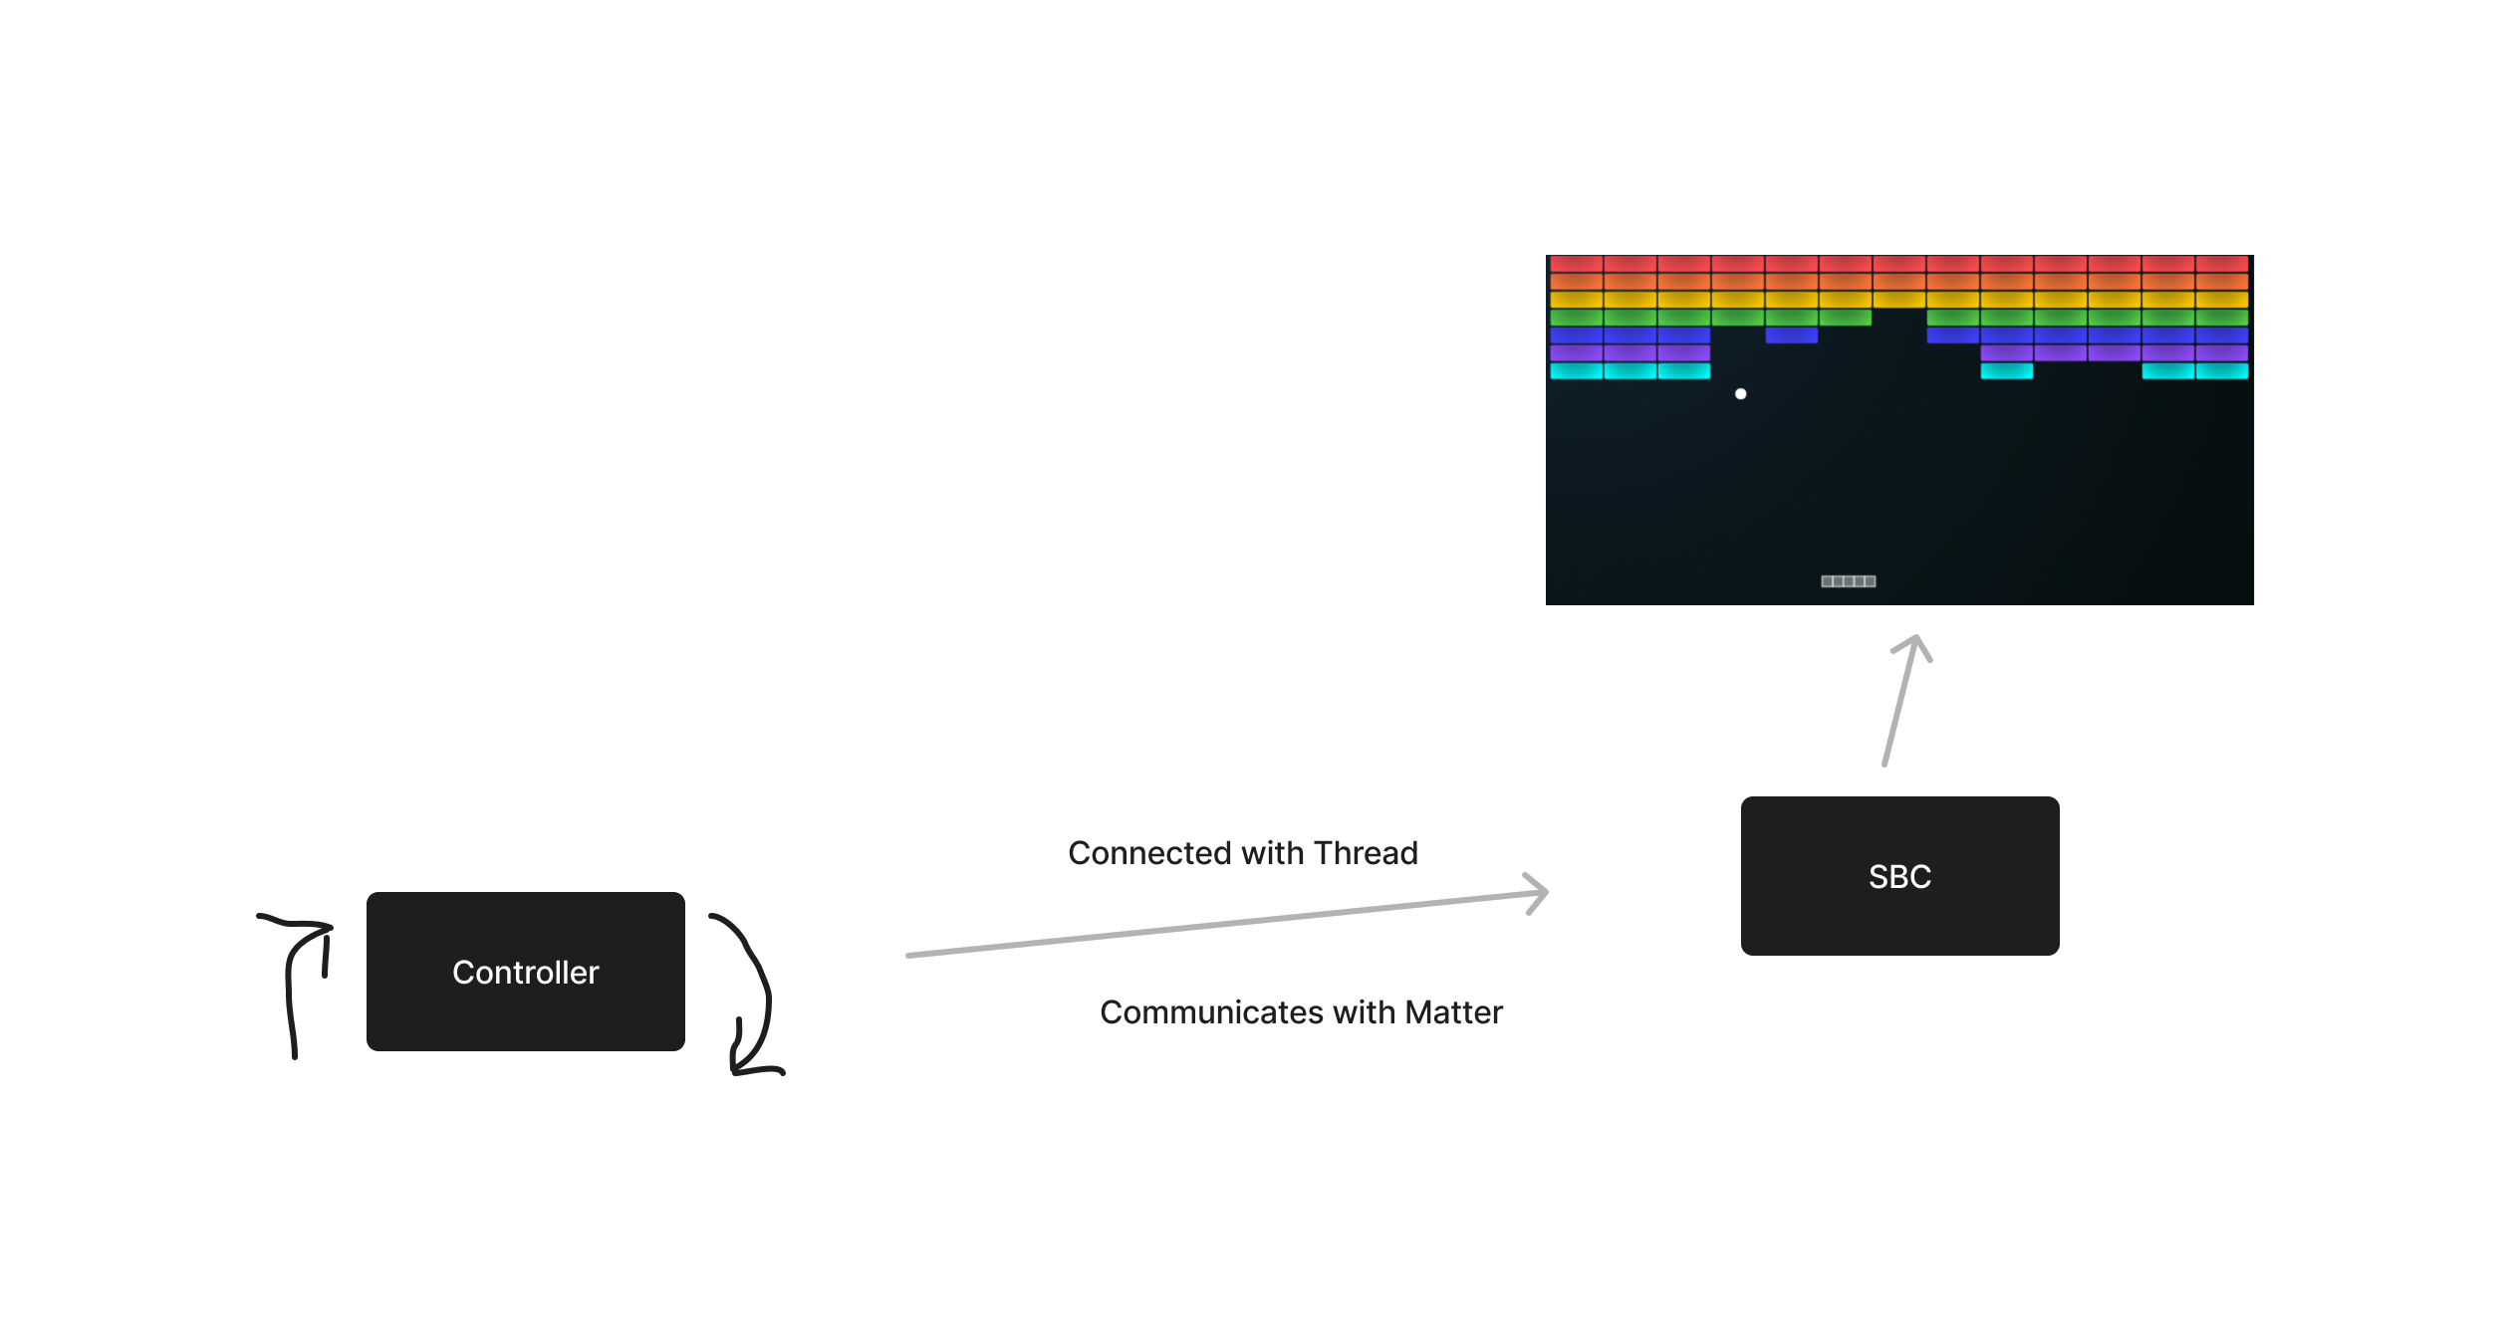

## Matter protocol

Matter, formerly known as “Project CHIP” (Connected Home over IP) is an open-source, royalty-free connectivity standard designed to make it easier for various smart devices to communicate with each other. It aims to create a unified standard for the Internet of Things devices. A Matter device can connect to a network with Thread, WIFI and Ethernet.

## OpenThread network protocol

OpenThread is an low-power mesh networking protocol that is based on IPv6. OpenThread is a open standard and is built for IoT applications. It uses 6LoWPAN which uses IEEE 802.15.4 (2.4Ghz) wireless protocol with mesh communication.

# Game controller

The wireless controller must be equipped with:

* 2.4Ghz wireless controller used for the OpenThread connection
* Accelerometer used to interact with the game (moving the bar)
* Button used for interact with the game (pause, start, etc.)
* A battery to provide power to the controller

## EFR32MG24 - BRD2601B Dev Kit

The EFR32MG24 Dev Kit board (BRD2601B) supports al the elements that is necessary for the controller. So there is no need to develop a PCB with al this components.

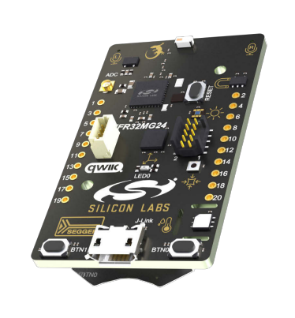 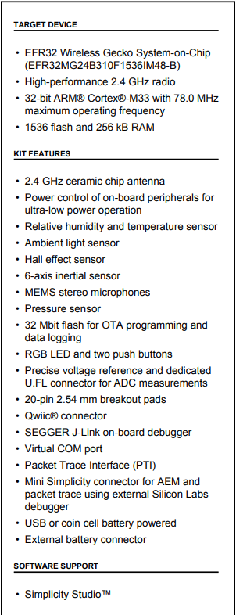

## EFR32MG24 Wireless SoC

The development board uses the EFR32MG24 wireless SoC (System on a Chip). This SoC is ideal for meshing wireless solutions using Matter and OpenThread. It provides al the built in features that are relevant for this project, like:

* High performance 32-bit 78 MHz Arm Cortex®-M33 processor
* 1536 kB flash and 256 kB of RAM
* High performance 2.4GHz Radio
* OpenThread and Matter support
* Security features for protection against hardware and software attacks
* A wide range of peripherals like I²C, SPI, USART, ADC, Timers, GPIO’s, etc.

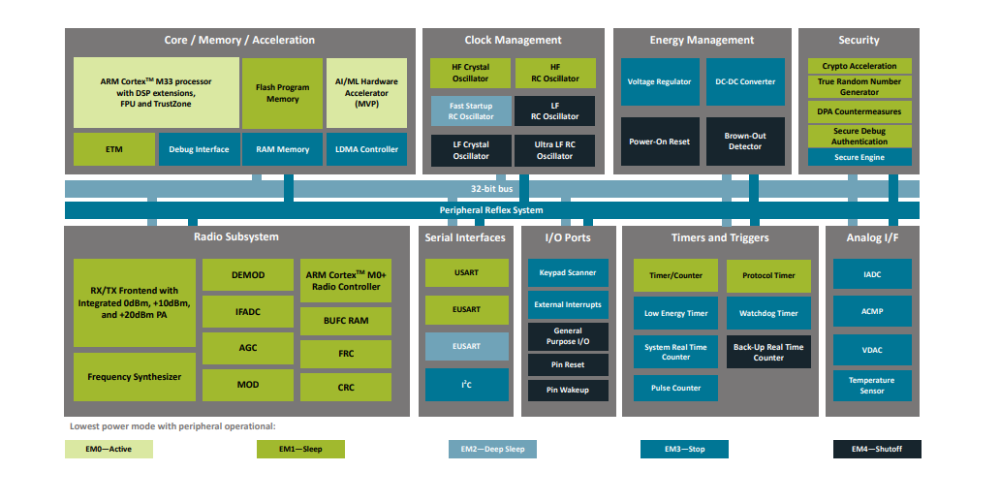

## ICM-20689 6-Axis sensor

The development board contains a 6-axis sensor ICM-20689. This 6-axis sensor combines a 3-axis gyroscope and a 3-axis accelerometer. It detects acceleration and angular rate in the X, Y and Z axes.

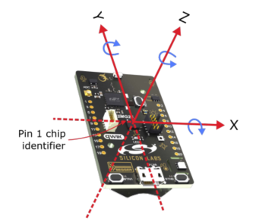

In the development board the sensor is connected an communicates over SPI. The SPI lines are interrupted trough a switch to prevent power consumption when not used. Before the sensor can be used in the application it must be enabled by setting PC09 high.

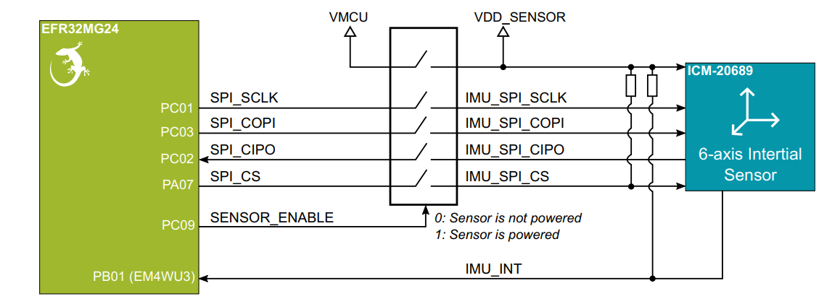

## User Button

The development board has two user buttons, BTN0 and BTN1. They are directly connected to the EFR32MG24 SoC and are debounced by RC filters.

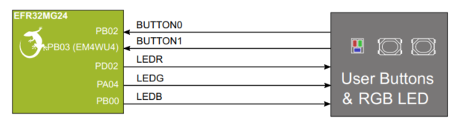

The buttons are connected to the pins PB02 and PB03. The pins are also available on the expansion header. The buttons on the board can be used during the development and later on we can use buttons in a case that are connected to the expansion header.

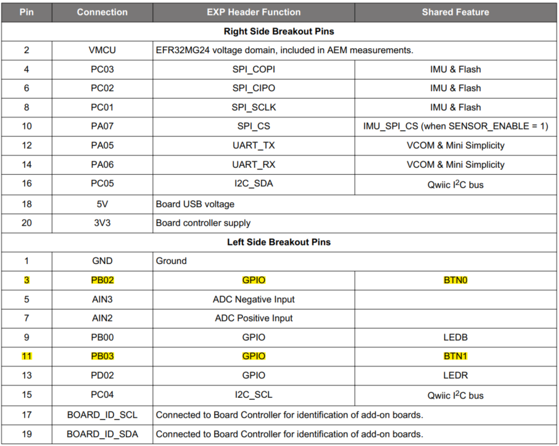

# SBC